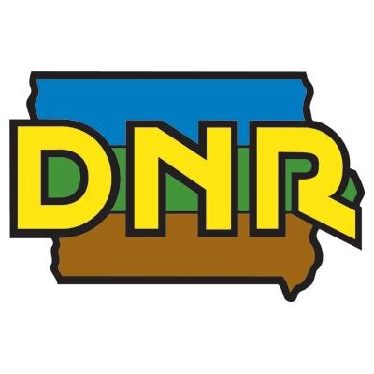
Polk Co. Urban Deer Management Zone Bowhunter Observation Survey
Iowa Department of Natural Resources

Thank you for participating in the Polk Co. DMZ Bowhunter Observation Survey!
This survey provides critical information to DNR staff that allows for better management of white-tailed deer, as well as many other wildlife species, in Polk county. Similar to last year, we are offering an online option for this survey. There are no differences between the online and paper version of this survey, but our hope is that offering both provides more flexibility.
Both versions of the survey require you to enter your DNR ID number, which can be found on any DNR-issued hunting license or tag, as well as on our “Go Outdoors Iowa” mobile app.
Please note that the URL and QR code has been updated since last year. The online survey can be accessed by either the weblink or QR code below:
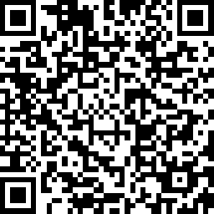
https://www.surveymonkey.com/r/polk-bowobs
Please choose only one format (paper or online) to submit all bowhunter observations each year.
If you have any questions regarding this survey, please call us at (515) 777-5378.
Thanks again, and good luck!

