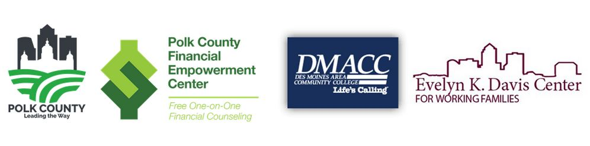

**Polk County Financial Empowerment Center Celebrates Milestone**

Financial Coaching Services Serves Thousands In First 3 Years

***DES MOINES, IA –***  On Monday, Polk County joined other community leaders to celebrate the 3-year anniversary of the [Polk County Financial Empowerment Center](https://evelynkdaviscenter.org/programs/fec.html). In March of 2020 the Polk County Board of Supervisors, in partnership with DMACC’s [Evelyn K. Davis Center for Working Families](https://evelynkdaviscenter.org/), launched the Polk County Financial Empowerment Center to provide professional, confidential, no-cost financial coaching to Polk County residents.

Polk County Board Chair Tom Hockensmith says, “Complementing many other services provided by the Board of Supervisors, the Polk County FEC is designed to help residents by completing a full financial health assessment, goal setting and development of strategies to reduce debt, increase savings, access safe and affordable banking and increase credit scores.  The goal of the center is to provide residents the tools to get ahead, not just get by. This service has helped participants accomplish that many times over.”

To date, the Polk County FEC has helped more than 1,100 clients, including 150 small business owners and entrepreneurs.  Coaches have provided more than 4,000 sessions, resulting in participants eliminating delinquent accounts, reducing debt by more than $2.8 million, saving more than $760,000 and increasing credit scores which helps with goals from purchasing cars and homes to opening a business.

 “FEC financial coaches are highly trained, kind and understanding”, says Eric Kool, the Polk County governmental manager of the FEC.  “They are determined to hear your story, help you work through financial troubles and celebrate success with you.  The Evelyn K. Davis Center has many other programs to help you succeed as well, and can make referrals to even more, so it a great place to get help”

The Polk County FEC opened during the start of the COVID-19 pandemic. This proved to be a consequential resource during a period of financial difficulty for so many residents. While the pandemic has officially ended, higher inflation continues to take a toll on families. The services provided at Evelyn K. Davis Center remain just as important as the day the FEC was founded and will be for years to come.

The Evelyn K. Davis Center for Working Families is located at the [DMACC Urban Campus](https://www.dmacc.edu/) in the heart of Des Moines and works to help families and individuals improve their financial position while also achieving their career goals. The Center serves thousands of Central Iowans every year.

####

**www.PolkCountyIowa.gov**

111 Court Ave

Des Moines, Iowa 50309

515-286-3120

For Immediate Release

April 24, 2023

Polk County

Board of Supervisors Office News