**Polk County To Resume Drive-Through COVID-19 Testing**

*Site to reopen after severe cold weather*

**Des Moines, IA-** Polk County will again offer drive-through COVID-19 testing starting on Saturday, January 22 at River Place (2309 Euclid Ave., Des Moines). The site opened on Monday with more than 500 residents tested in the first day. Extreme cold temperatures forced the site to close on Wednesday.

The site will be open 7 days a week. Hours are 8AM- 6PM each day. Those who utilize the drive-through sites are asked to bring an insurance card and a current ID. There is no cost for symptomatic or exposed individuals. Results from PCR tests are sent to individuals within 48 hours. Rapid tests are also available upon request.

Those using the sites are asked to plan accordingly and expect occasional wait times. Drive-through testing is a partnership between Polk County and Wellpath. Residents are encouraged to visit PolkCountyIowa.gov for any updated information or announcements prior to visiting the site.

####

**www.PolkCountyIowa.gov**

111 Court Ave

Des Moines, Iowa 50309

515-286-3120

For Immediate Release

January 21, 2022

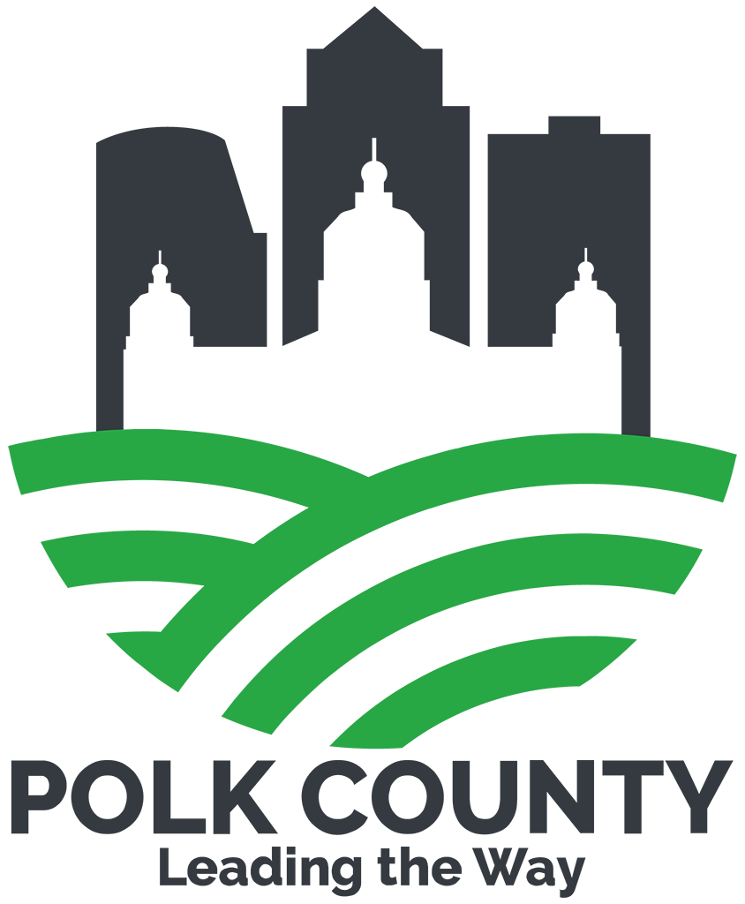

Polk County

Board of Supervisors Office News